A000-Mex-Olmec-Were Jaguar-Pendant-1200-900 BCE

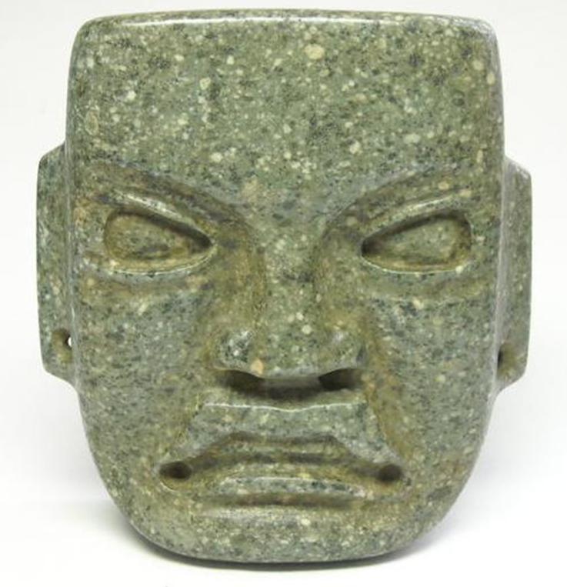

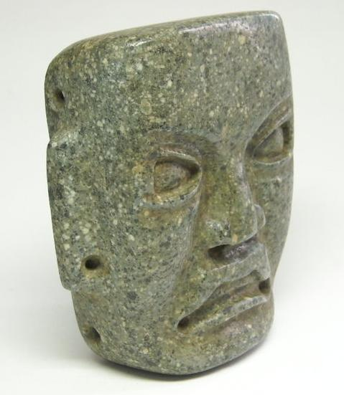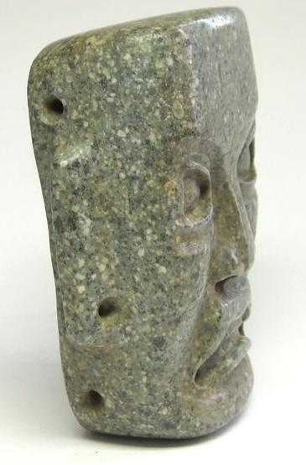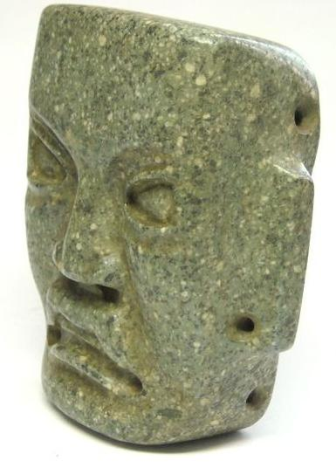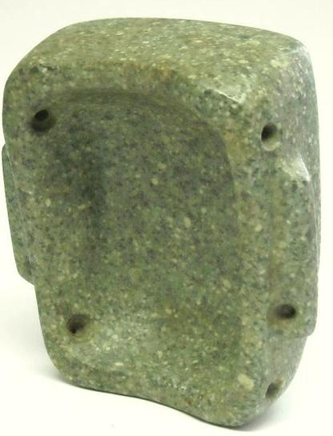

Figs. 1-5. Olmec-Were Jaguar-Pendant-1200-900 BCE

Case 10.

**Formal Label:** Olmec-Were Jaguar-Pendant-1200-900 BCE

**Accession Number:**

* **LC Classification:** F1219.8.O56

**Display Description:**

Two of these jade faces represent the Olmec Maize God, the preeminent Olmec deity; he can be identified by his upturned lip, easily visible on the mask with the round eyeholes. Olmec masks were not always meant to be worn on the face. One example lacks openings for the eyes and mouth, and perforations along the sides suggest its ritual use as a belt ornament, pectoral, or headdress. The deep blue color of this mask’s jade made it the most valued material for the Olmecs.

**Date or Time Horizon:** 1200-900 BCE

**Geographical Area:** Cuautla, Morelos, Mexico

**GPS:**

|  |  |
| --- | --- |
| Longitude | -98.945550 |
| Latitude | 18.804590 |

Map:

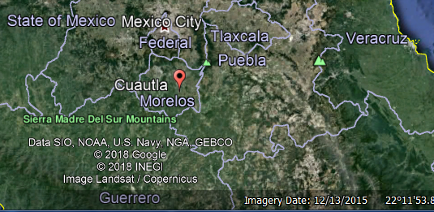

**Cultural Affiliation:** Olmec

**Medium:** Amphibolite

**Dimensions:**

**Weight:**

**Condition: original, no defects**

**Provenance:** Cuautla, Morelos, Mexico

**Discussion:**

Depicting a typical Olmec face with slanted, almond-shaped eyes and a toothless, slightly downturned mouth, this mask is rendered with simplicity and elegance. Its harmonious proportions are indicative of the sophistication attained by Olmec sculptors. The smooth, highly polished planes of cheek, forehead, and chin plus the almost fleshy quality of the nose and parted lips belie the incredible hardness of the jadeite cobble from which the mask was made. The face itself is neither human nor supernatural but, rather, an idealized type that incorporates otherworldly aspects—such as the mouth, with its reference to the so-called were-jaguar, a powerful mythic being with human and jaguar traits.  
  
Masks of this size in stone have not been excavated in archaeological sites and it is difficult to determine their function. Lacking holes for eyes and nose, it could not have been worn over a living face, but there are attachment holes along the edges by means of which it might have been used as a costume element or adhered as a face to a mummy or a sacred bundle. There is a polished, circular depression on the back of the mask.

**References:**

Clark, John E., Mary E Pye; National Gallery of Art (U.S.). 2006. *Olmec art and archaeology in Mesoamerica.* Studies in the history of art, 58. Symposium papers. New Haven: Yale University Press.